**Sprint planning 2**

AutoMate

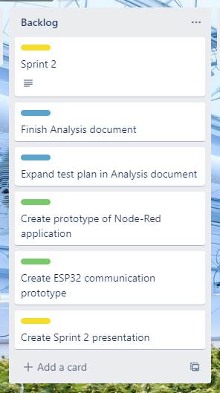

Above you see our Trello sprint board and there we include our planning. Our main goal for Sprint 2 is to have a stable communication prototype that we can enhance in future implementations. The communication also includes a Node-Red dashboard where we will aim to have a finished prototype before Sprint 2. In the diagram below we created a small indication of what the first implementation will look like.

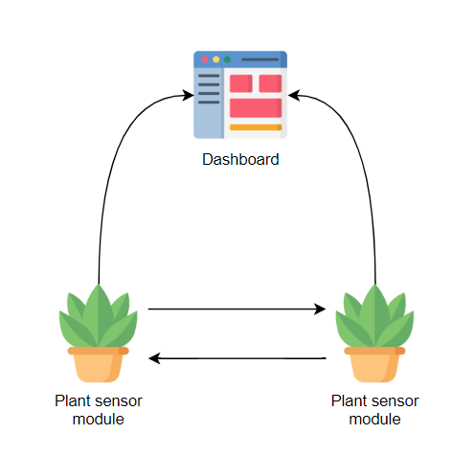

With these prototypes finished, we will have a good steppingstone to enhance them in the way that is most appropriate for our final system.

A side goal is to finish our analysis document and to expand our test plan. After we have finished these tasks, we will have to create a presentation for the second sprint and make a new plan for Sprint 3.